4.0 Voice and Wireless Design
According to the specification in the WWTC Business and Technical requirement, the design of the wireless network should provide a very fast and secure wireless connection in the lobby as well as the two large conference rooms in the organization.
For efficient full Wireless Access Points (WAP) coverage to the lobby and the two conference rooms and for the fact that the target areas are located apart within the office, a Cisco Aironet 1250 Series WAP will be configured in each of the rooms and the lobby. The Aironet 1250 will be an ideal choice for the conference room due to a lot of high bandwidth usage in terms of voice, data and video applications used in these areas. The WAP is also a dual band device with multiple channels capable to limit channel overlapping during high traffic usage, supports rogue access detection, able to detect malicious users and alert the administrator. A Cisco 4400 Series Wireless LAN Controller will be added to the WAP used to provide single management point for real-time communication to and from the WAP and will deliver centralized security policies, intrusion detection and prevention capabilities, quality of service and efficient mobility service.
The WLC connect to the access layer PoE switches and configured with three VLANs: WWTC employee, WWTC guest, and voice for wireless phones. In order to ensure maximum bandwidth and reduce RF interference, these APs will be placed in the center of each location and will be configured to use 802.11g (supports the 54 Mbps bandwidth requirement) with the 2.4 GHz frequency. The 2.4 GHz frequency is the best frequency to use since other devices such as microwaves use the 5 GHz frequency and if the APs use the 5 GHz frequency, there will be risk of RF interference. The APs are going to be mounted at each end of the two conference rooms and the lobby area instead of overhead so that it does not negatively affect each of the rooms’ aesthetics. To maximize channel and bandwidth usage, the APs will be installed at eight feet from the floors in each room and will face downward at 40 degrees. The antennas will be directional in order to ensure adequate coverage and the APs in the two conference rooms will use separate channels (channels 6 and 11) in order to prevent similar channels from interfering with each other at the overlapping point. For the lobby APs, they will be placed at each end at eight feet from the floor and will face downward at 40 degrees. Both antennas will be directional in order to ensure adequate coverage along with using separate channels (6 and 11) to mitigate channel interference.
For security, all of the access points will use 802.1x (WPA2 Enterprise) authentication where all WWTC users and guests must provide their username and password (guests will be provided a temporary username and password) before authenticating onto the WLAN. The 802.1x standard also features encryption via EAP. This ensures confidentially since unauthorized users, such as a war driver using a packet sniffer to view transmitted data over the WLAN, cannot view the data. VLANs will be configured on the WLC that will separate traffic on the WLAN. The names of the VLANS are: WWTC employees, WWTC guests, and voice. Employees in WWTC’s NYC office will be on the WWTC employees VLAN, external users who need to access WWTC’s WLAN any of the three locations will be on the WWTC guests VLAN, and the voice VLAN will be configured to handle wireless phone communication.

Below is the diagram for the wireless Network Layout.
Network Layout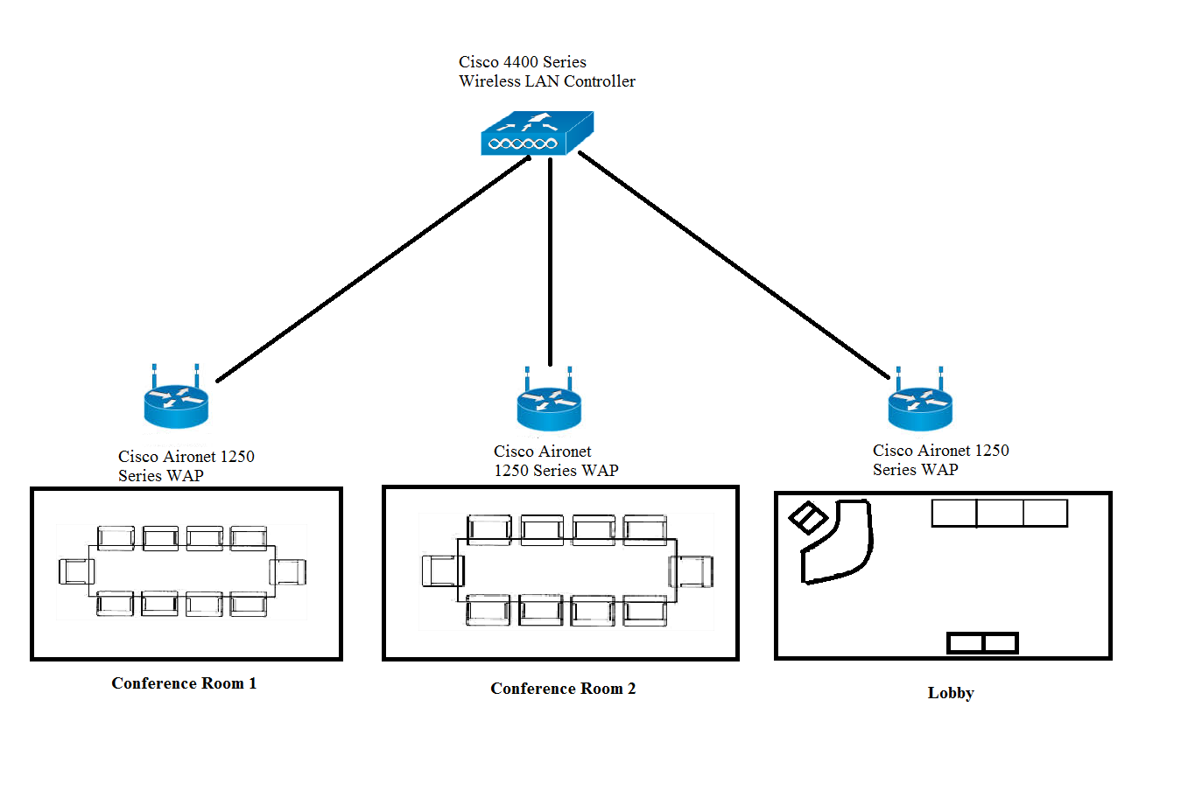
Wireless Access Point Installation and Configuration
Location of AP | Name of APs | AP Configuration Summary
Lobby | WWTC_Lobby1.1 | The AP will be mounted at each end of the lobby eight feet from the floor, directly in the center of the lobby. The antenna will be directional in order to adequate coverage for the users. The APs will use separate channels in order to prevent channel interference along with using 802.11g for bandwidth and 2.4 GHz frequency.
Conference Room 1 | WWTC_Conf1.1, | The AP will be mounted at each end of conference room 1 eight feet from the floor, directly in the center of the lobby. The antenna will be directional in order to adequate coverage for the users. The APs will use separate channels in order to prevent channel interference along with using 802.11g for bandwidth and 2.4 GHz frequency.
Conference Room 2 | WWTC_Conf2.1, | The AP will be mounted at each end of conference room 2 eight feet from the floor, directly in the center of the lobby. The antenna will be directional in order to adequate coverage for the users. The APs will use separate channels in order to prevent channel interference along with using 802.11g for bandwidth and 2.4 GHz frequency.

WWTC requires a Voice over IP (VoIP) solution that will reduce costs and maintain 100% connectivity. The VoIP implementation must also be scalable to provide for future growth and have fault tolerance. The New York office will need to separate VoIP from the network to prevent interference of the lines and congestion over the network. When used as a singular entity, VoIP traffic will suffer from decreased bandwidth when there are delays or other issues over the network. By keeping VoIP on its own dedicated VLAN, these issues will be avoided. The VLAN will also make it easier for administrators to manage the VoIP network. Unified Communications Manager can be used to both monitor and manage IP telephony and video services throughout WWTC. The Cisco Business Edition 6000 offers most elements of the Unified Communications Manager console to include VoIP and video messaging services.
Outside telephone lines will be used through public switched telephone network (PSTN) channels. WWTC’s executive staff and brokers will be making commercial calls outside of the organization and will need PSTN phone lines. Due to the number of users (around 28) and the expected heavy call volumes to be made, it is estimated that executive staff and brokers will need about six PSTN channels at a 5:1 person per channel ratio. For redundancy, voice-network dial peers can be established to maintain 100% connectivity.
OH | PS | Total | PR | BW | BW | Peak users | BW Total
10 bytes | 20 bytes | 30 bytes | 50 pps | 1.5 KBps | 12 Kbps | 70% | 840 Kbps
OH – Overhead PS – Packetization Size PR – Packet Rate BW – Bandwidth KBps – Kilobytes per second Kbps – Kilobits per second pps – packets per second
Calculation: Overhead + Packetization Size x Packet Rate = Bandwidth
Using the VoIP bandwidth calculator, with the G.729 codec the bandwidth for a single VoIP call will need 12 Kbps. The total bandwidth for voice calls will need to be at least 840 Kbps, on the assumption that that 70% of the WWTC staff are using VoIP phones during peak hours.

VoIP Diagram

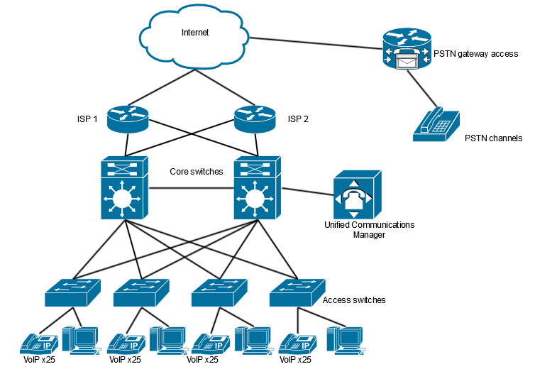

References

Cisco. (2011). Wireless LAN Design Guide for High Density Client Environments in HigherEducation. Retrieved June 2, 2016, from Cisco:http://www.cisco.com/c/dam/en_us/solutions/industries/docs/education/cisco_wlan_design_guie.pdf.
Cisco ASA 5500-X Series Next-Generation Firewalls - Products & Services. (n.d.). Retrieved June 1, 2016, from http://www.cisco.com/c/en/us/products/security/asa-5500-series-next-generation-firewalls/index.html?referring_site=bodynav.
Cisco ASR 1001 Router. (n.d.). Retrieved June 1, 2016, from http://www.cisco.com/c/en/us/products/routers/asr-1001-router/index.html
Cisco Aironet 1250 Series Access Point Data Sheet. (n.d.). Retrieved June 2, 2016, from http://www.cisco.com/c/en/us/products/collateral/wireless/aironet-1250-series/product_data_sheet0900aecd806b7c5c.html
Cisco Catalyst 3560 Series Switches - Products & Services. (n.d.). Retrieved June 2, 2016, from http://www.cisco.com/c/en/us/products/switches/catalyst-3560-series-switches/index.html
Cisco IPS 4270-20 Sensor. (n.d.). Retrieved June 2, 2016, from http://www.cisco.com/c/en/us/support/security/ips-4270-20-sensor/model.html

Cisco Secure Access Control System - Products & Services. (n.d.). Retrieved June 3, 2016, from http://www.cisco.com/c/en/us/products/security/secure-access-control-system/index.htmlhttp://www.cisco.com/c/en/us/products/collateral/unified-communications/unity-express/reference_guide_c07-566560.html.
Cisco Unified IP Phone 7942G Data Sheet. (n.d.). Retrieved June 3, 2016, from http://www.cisco.com/c/en/us/products/collateral/collaboration-endpoints/unified-ip-phone-7942g/product_data_sheet0900aecd8069bb68.html
Cisco Wireless LAN Controllers. (n.d.). Retrieved June 2, 2016, from http://www.cisco.com/c/en/us/products/collateral/wireless/4100-series-wireless-lan-controllers/product_data_sheet0900aecd802570b0.htm
Cisco Unified Communications 500 Series Model 560 for Small Business: Platform Reference Guide. (n.d.). Retrieved June 3, 2016, from Technet. (2016). Windows Deployment Services
Dell Precision Tower 3000 Series (3420). (n.d.). Retrieved June 5, 2016, from http://www.dell.com/us/business/p/precision-t3x20-series-workstation/pd?oc=xctop3420sffus_4&model_id=precision-t3x20-series-workstation&l=en&s=bsd
HP Color LaserJet Pro MFP M527n. (n.d.). Retrieved June 2, 2016, from http://store.hp.com/webapp/wcs/stores/servlet/us/en/pdp/printers/hp-color-laserjet-pro-mfp-m176n
HP NC365T 4-port Ethernet Server Adapter. (n.d.). Retrieved June 2, 2016, from http://h18004.www1.hp.com/products/servers/networking/nc365t/index.html

TestOut. (n.d.). DHCP Subnetting [Video file]. Retrieved from http://cdn.testout.com/client
v5-1-8-81/startlabsim.html?culture=en-us.

